***CO438 DIFOT Lobby Element and Report***

|  |  |  |  |  |
| --- | --- | --- | --- | --- |
| **Ver** | **Date** | **Author** | **Comments** | **Reviewed by** |
| 1 | 18/12/2020 | Linzi Evans |  | TBC |
|  |  |  |  |  |

Requirements 2

Prerequisites 2

Solution Overview 2

Solution Details 2

Security 3

Companies 3

Data Migration 3

Test Steps 3

Technical Implementation 3

Requirements

Report that looks at weekly / monthly / annual performance of Customer Order to Delivery.

Key Aspect is; Delivered in full on time.

IFS offer an out of the box report: Delivery Reliability, however, specific improvement required to suit the business.

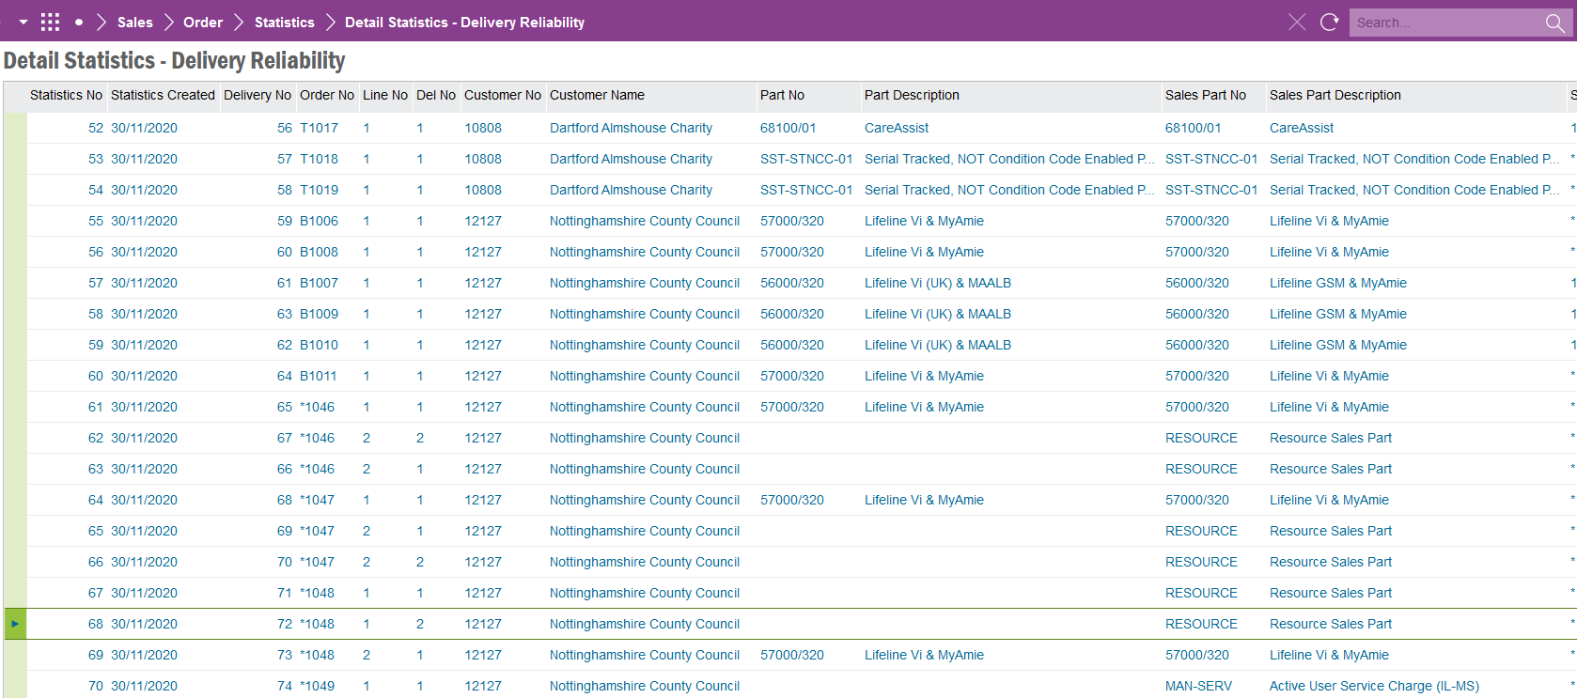

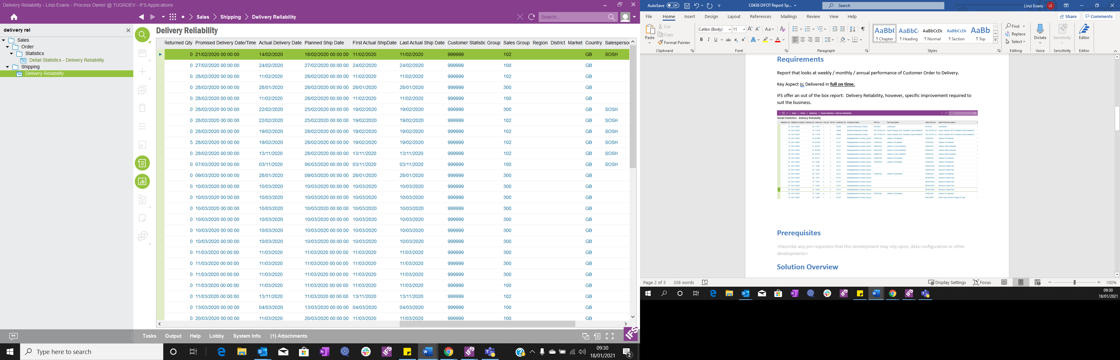

Prerequisites

<Describe any pre-requisites that this development may rely upon, data configuration or other developments>

Solution Overview

Report to be enabled so that can be filtered by order type. i.e. All / multiple / specific.

Should be able to dictate period of reporting. Eg. Weekly, monthly, quarterly, annually.

Solution Details

There are 2 parts to the calculation.

1. The calculation is:

*Delivered in full* is difference between Sales Quantity and Delivered Quantity:

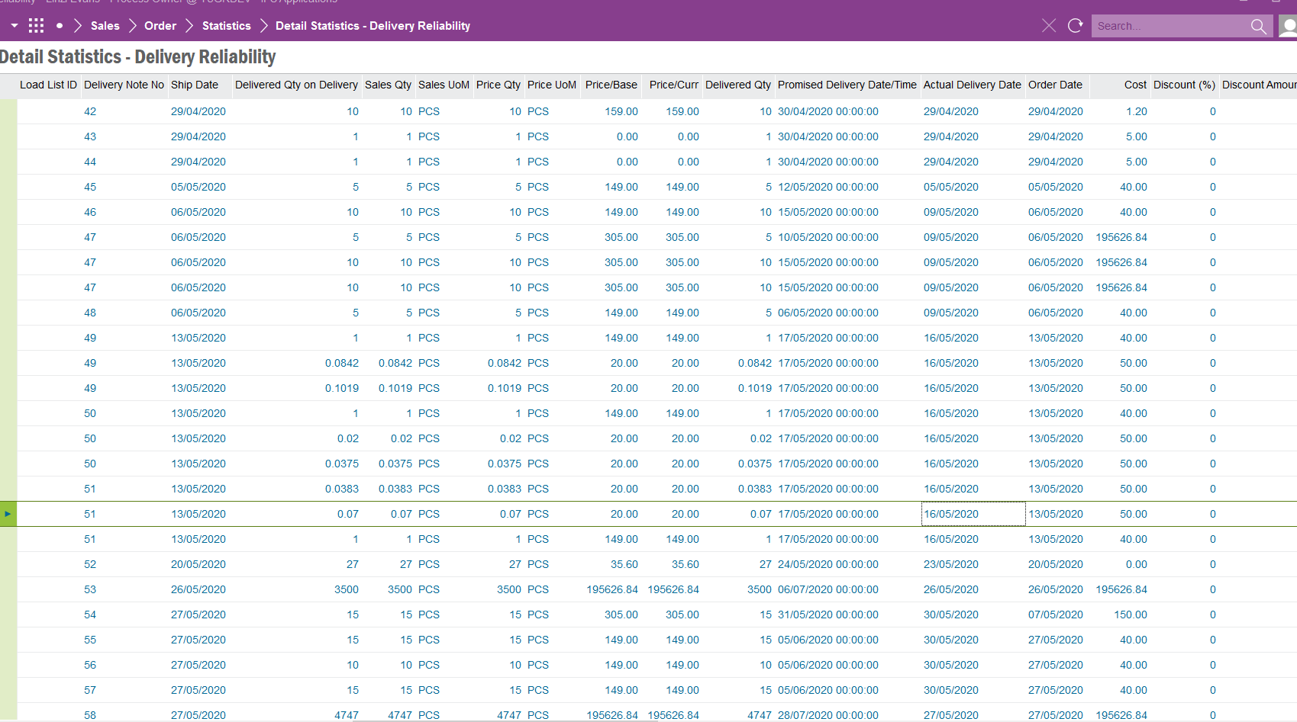

The *On time* metric is the difference between promised delivery date and actual delivery date:



Table to Show:

|  |  |  |  |  |  |  |
| --- | --- | --- | --- | --- | --- | --- |
| **Number of Orders** | **Total Sales Quantity** | **Total Delivered Quantity** | **Number of Sales Delivered in Full** | **Number of Deliveries on Time** | **Total Number of Deliveries** | **Shown as a %** |
| In selected time period | In selected time period | In selected time period | In selected time period | In selected time period | In selected time period | As below |

Calculation as a percentage =

x 100

**NOTE:**

**There is a lobby element as below: **Can we please look into the calculation behind this?\*\***

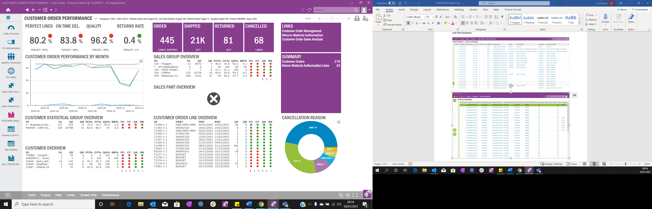

Field Definitions.

<New Field/CLU Definition>

|  |  |  |  |  |  |  |
| --- | --- | --- | --- | --- | --- | --- |
| New DB Object Name | DB Object Item/Field Names | Item Description | Item Data Type | Item Syntax | Calculation Spec, if Derived | LOVs/Enums/Is Mandatory? |
|  |  |  |  |  |  |  |
|  |  |  |  |  |  |  |
|  |  |  |  |  |  |  |
|  |  |  |  |  |  |  |
|  |  |  |  |  |  |  |
|  |  |  |  |  |  |  |
|  |  |  |  |  |  |  |
|  |  |  |  |  |  |  |
|  |  |  |  |  |  |  |
|  |  |  |  |  |  |  |
|  |  |  |  |  |  |  |
|  |  |  |  |  |  |  |

Security

Anyone with a sales base profile.

Companies

Applies to the following companies

|  |  |
| --- | --- |
| **Company** | **Required (Y/N)** |
| 1201 | Y |
| TBC |  |
|  |  |

Data Migration

<Describe any data migration impacts this development may have – i.e additional data to be migrated>

Test Steps

<Steps that needs to be taken to test this change. Please provide expected results>

|  |  |  |
| --- | --- | --- |
| **No** | **Script\Test Steps** | **Expected Result** |
| 1. | Run DIFOT Report | Table to show as above, DIFOT % to be accurate. |
|  |  |  |
|  |  |  |
|  |  |  |
|  |  |  |
|  |  |  |

Technical Implementation

**Quick Report**

Report Title: Delivery Reliability Report

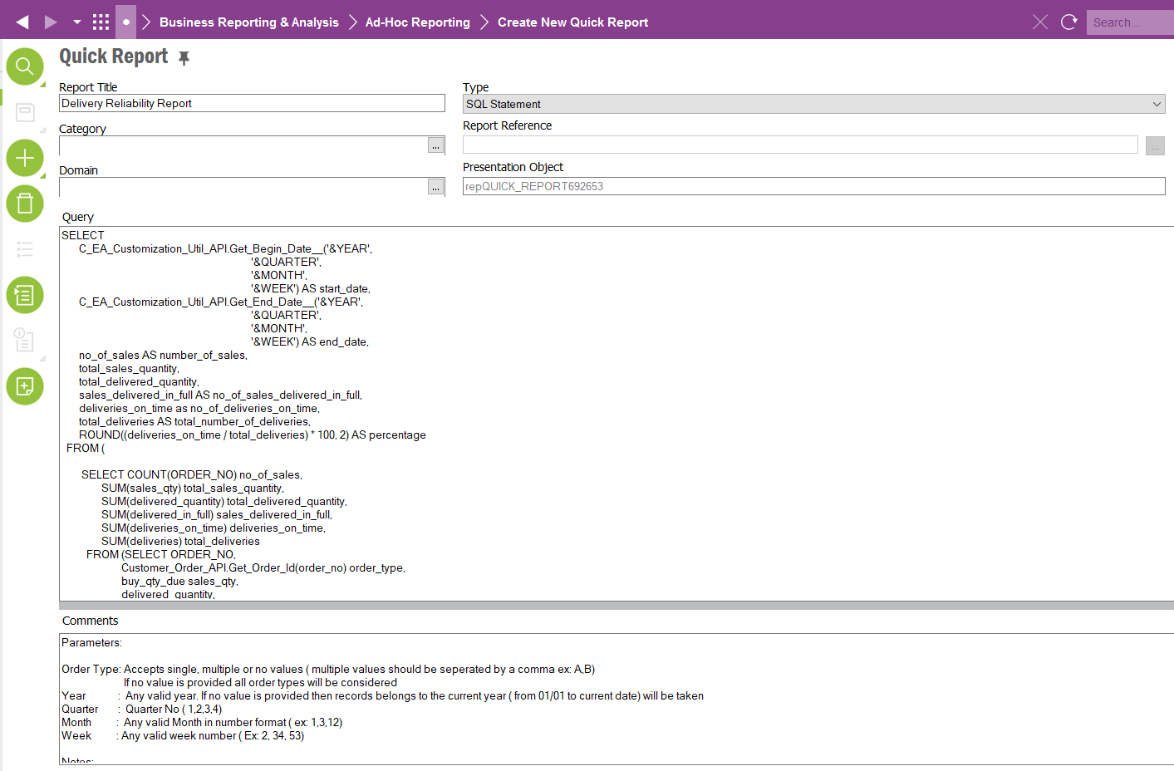

Report Parameters:

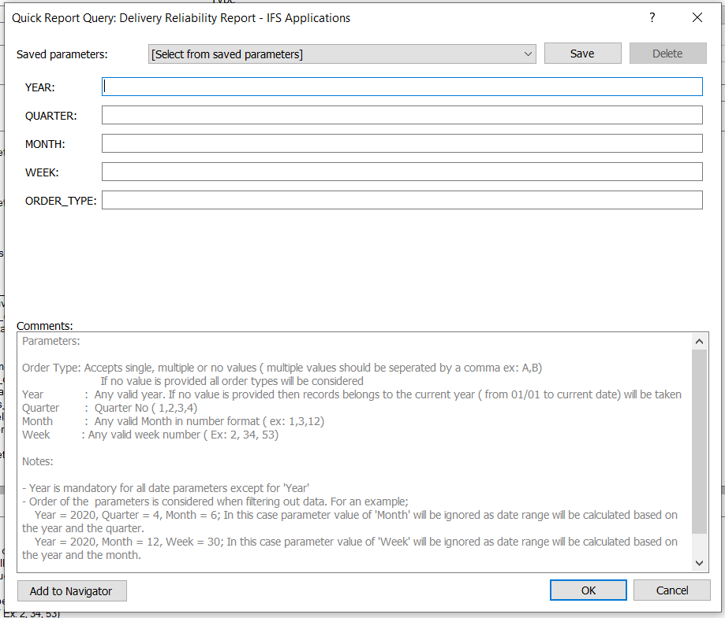

Order Type: Accepts single, multiple or no values ( multiple values should be separated by a comma ex: A,B). If no value is provided all order types will be considered

Year : Any valid year. If no value is provided then records belongs to the current year ( from 01/01 to current date) will be taken

Quarter : Quarter No ( 1,2,3,4)

Month : Any valid Month in number format ( ex: 1,3,12)

Week : Any valid week number ( Ex: 2, 34, 53)

Notes:

- Year is mandatory for all date parameters except for 'Year'

- Order of the parameters is considered when filtering out data. For an example;

Year = 2020, Quarter = 4, Month = 6; In this case parameter value of 'Month' will be ignored as date range will be calculated based on the year and the quarter.

Year = 2020, Month = 12, Week = 30; In this case parameter value of 'Week' will be ignored as date range will be calculated based on the year and the month.

Report Result:

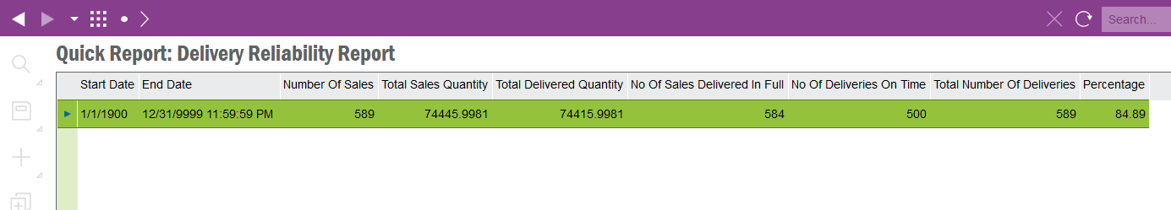

Note:

Start Date: Start Date of the period. In case no parameters are provided this will be set to 1/1/1990

End Date: End Date of the period. In case no parameters are provided this will be set to 31/12/9999